

American International University-Bangladesh (AIUB)  
**Department of Computer Science  
Faculty of Science &Technology (FST)  
Summer 19_20**

**Section: D  
Group No: 4**

**PROJECT TITLE: CALL IN A DOCTOR**

A software Engineering project submitted

By

|  |  |  |
| --- | --- | --- |
| SL | Student Name | Student ID |
| 36 | SAHA, ATANU | 18-38429-2 |
| 35 | MIAH, MD.BADHON | 18-38225-2 |
| 34 | HASSAN, TANVIR | 18-38060-2 |
| 37 | MAHMUD, MD. AFSAR | 18-38443-2 |

The project will be Evaluated for the following Course Outcomes

|  |  |
| --- | --- |
| CO3: Choose appropriate software engineering model in a software development   environment | Total Marks |
|  |
| Project Background Analysis (problem, needs, goal, benefits, etc.) [5Marks] |  |
| Appropriate Process Model Selection and Argumentation with Evidence [5Marks] |  |
| Completeness, Spelling, Grammar and Organization of the Answer [5Marks] |  |
|  | |
| CO4: Explain the roles and their responsibilities in the software project   management activities | Total Marks |
|  |
| Content Knowledge (e.g. System Requirements, System Design) [5Marks] |  |
| Project Role identification and Responsibilities descriptions [5Marks] |  |
| Presentation Delivery and Defense [5Marks] |  |

**Root cause of this problem**

Being hospitalized or getting treatment has always been a huge problem in our country as we have less hospital and less doctor as per we need. Sometimes we don't have the time to check door to door of every hospital to get appointment for a doctor or getting an ICU. If somehow we can reduce this problems there will be a huge chance to save a life. Now a days, our country is going through with such a pandemic where getting treatment has become a huge problem. That's why we want to develop a system which can reduce such kind of problem for which we are suffering like getting appointment from a doctor or getting an ICU etc.

**Top of Form**

**Bottom of Form**

**Project objective:**

Our goal will be to create a vast no. of community where there will be all the facilities to give a person his/her proper health treatment about his physical condition. It merges with the resources we have in our medical ministry with the information technology field, whereas the programming of data processing systems evolved into standardized routines and packages of enterprise resource planning (ERP) software. This linkage between medical accessories and human resources we have to be fully utilized.

**What are solution?**

In this situation, many hospitals are closed, that’s why peoples are suffering day by day. We decided to solve this problem through online. People can use this software to contact with doctors immediately. This software also will be easily useable.

In this software, doctors can register there profile and set how much fee he/she want. Patient can easily log in and request for the doctors and then the doctor will accept his/her request and send the time for visit.

In this software there will be 3 categories for the patients:

1. Normal sickness,
2. Critical Situation,
3. Call in a doctor.

**Special Feature:**

1. The biggest problem in this situation in ICU problem. This problem is the cause of suffer of many people till now. So, keeping this in on our mind we have decided to add a feature that will show the available ICUs and booked ICUs. So that people don’t need to run different hospitals for ICU.
2. For the poor people there will be an option named “Free Doctor”. This option will be useable only in a selected day by the doctors.

**Targeted people and benefits:**

We develop this software for all the people who want a smart solution for their any kind of health issues. This software is for everyone and well-being of the people. Patients can easily use this software when they are sick. This project is not only based on Covid-19 situation, it can be used when some needs a doctor or ICU whenever they want.

Every day we face lots of problem regarding the health issues. In normal time, it will help us to find doctor and also we can select the proper hospital. It will make our life easier and also by this software we can also call doctor at home, it will be helpful for some cases. In this pandemic situation, everyone face many problem regarding the health issues. The patient who are not effected in covid-19 or the patient who are effected both are facing lots of problem to find doctor or ICU. On the other hand lots of ICU is available but the patient can’t find those they go here and there and loss their valuable time as well as sometimes their life. For this problem, we want to develop this project called calling a doctor that can help people to find out doctor as well as ICU .Overall this software help us for our daily or critical health issues solution.

**Functionality Overview:**

Here are the all features of this software:

1) Simple log in process.

2) Making profile of doctors.

3) 3 categories for visit a doctor.

4) Immediate ICU.

5) Booking an ICU.

6) Free Doctors.

7) Online Payment.

**System Features:**

1. **Software Registration**

**Functional Requirements**

**Registration:**

This software shall allow registration both for patients and doctor as far user need.

**For user (Patient)**

* 1. User have to provide his username (if the name is available otherwise system will suggest some usernames or user can make his/her username unique), user password (password must be at least 6 digit and it should contain some special character), address, date of birth, email, phone number for verification. User must have to provide all the requirements that system requires.
  2. After user submits the form then system will send a verification code to user phone number (Within 2 min). User have to enter this verification code. Wrong submission more than 5 time will freeze the login system for a certain amount of time.
  3. If user failed to enter the correct code then user have to fill the form again.
  4. After successful verification, registration is complete.

**For user (Doctor)**

* 1. User have to provide his username (if the name is available otherwise system will suggest some username or user can make his/her username unique), user password (password must be 6 digit or grater and it should contain some special character) , address, date of, birth email, phone number, documents like certificates, NID, specialization for verification.
  2. System will take 3 days maximum time to verify all the information and send a verification code via phone number.

System will ask 2 question to the doctors to select:

1. Call in a doctor
2. Free treatment

1.7) Doctors can mark “Yes” or “No” to this services if they are interested.

**Priority Level:**  High

1. **Software login**

**Functional Requirements**

2.1) Software shall allow user to login with the registered username and password.

2.2) If the username or password has been inserted wrong for more than 5 times the security purpose mail will be sent to the user mail and ask for change password if user want.

**Priority Level:**  High

**Precondition:** Registered username and password

1. **Online doctor**

**Functional Requirements**

3.1) Specialized doctors from each department available within that day will be shown in this system feature.

3.2) User can choose an available specialize doctor according to his/her condition.

3.3) User have to pay the visit of doctor for confirming the appointment.

3.4) After confirmation system will provide a serial number to the user.

3.5) System will automatically add the user in queue and according to the queue list user will be called by the doctor. After the meeting user will pop.

**Priority Level:**  High

**Cross reference:** Registration, Online payment.

1. **Meet a doctor**

**Functional Requirements**

4.1) User can choose an available specialize doctor according to his/her condition.

4.2) System will give an appointment request to the doctor’s chamber and from the doctors chamber a serial number and time , date will be provided manually to the system.

4.3) System will provide that serial number and time, date to the user. If the user is satisfied with the time, date then he/she have to confirm the appointment with a booking fee (20tk).

**Priority Level:** High

**Cross reference:** Registration, Online payment.

1. **Call in a doctor**

**Functional Requirements**

5.1) In this feature user can call a doctor in his/her home when there is an emergency.

5.2) In this feature system provides the available doctors list who are registered for giving this service according to user location.

5.3) User have to choose his/her desired specialized doctor from the provided list.

5.4) Then user have to send a request through system to the doctor.

5.5) If doctor accept the request user have to pay doctors fee.

5.6) After payment, system will send a notification to the doctor that schedule is confirmed.

5.7) In the schedule day after the meeting both doctor and user will confirm that service is done via system.

5.8) Then through the system user will find a review box, where he/she can give feedback.

5.9) For any query user/doctor can use systems helpline via phone call.

**Priority Level:** High

**Cross reference:** Registration, Online payment.

**6) Immediate ICU**

**Functional Requirements**

6.1) In this feature user can find several hospital’s where ICU’s are available according to city.

6.2) Management of the hospitals will continuously update the ICU’s information (like how many beds are already in used and available) in the systems website.

6.3) Hospitals with (ICU beds) database will be connected to systems server.

6.4) User can see available hospitals hotline number so that they contact with hospital’s emergency center.

6.5) This feature is free for everyone.

**Priority Level:** High

1. **Free Doctors (Online)**

**Functional Requirements**

7.1) It will occur once a weak.

7.2) Doctors will update their free hour on that day.

7.3) System will show doctors availability before the free consulting day.

7.4) Pre booking a slot for free doctors will be available before the day of free consulting.

7.5) To confirm the slot user have to pay system fee (20BDT) within a fixed time duration.

7.6) After payment a serial number and possible time will be send to the user and the doctor via SMS.

**Priority Level:** Medium

**Cross reference:** Online payment.

1. **Online Payment**

**Functional Requirements**

**For online service:**

8.1) After clicking on the payment option user have to pay doctors fee and system charge (10% of the doctors fee).

8.2) Payment method:

1. bKash (<https://www.bkash.com/bn>)
2. Nagad (<https://nagad.com.bd/>)

**Priority Level:**  High

**Cross Reference:** Online doctor, Call in a doctor, Free doctor, Visit a doctor.

**Non – Functional Requirements**

1. **Availability:**

99.25 percent available on weekday from 6:00am to 11:59pm and 99.85 percent available on weekends from 8:00am to 11:59pm. 98.5 percent available from 12:00am to 5:59am on both weekdays and weekends.

1. **Performance:**

2.1) Authentication process shall take between 2 minutes.

2.2) Web pages shall load within less than or equal 12 seconds over a speed of 80kbps connection.

2.3) All kinds of searching strategies should give results within 10 seconds.

2.4) Payment validation should be confirmed within 15 seconds.

1. **Efficiency:**

3.1) According to user’s internet speed, system will automatically reduce/increase images quality to give user a smooth experience.

1. **Integrity:**

4.1) System is able to prevent unauthorized access.

4.2) System will not contain any kind of virus materials.

4.3) Only permitted privileges will be able to access user transaction histories.

4.4) Payment transactions procedure will be handled in special security.

1. **Interoperability:**

5.1) ICU information from every hospital will be updated in the system database.

5.2) Symmetric communication between system and payment methods will be establish when a transaction is occurred.

1. **Reliability:**

6.1) System will response more than or equal 99 times within 100 times.

1. **Robustness:**

7.1) All activities like filling up form or taking appointment for a doctor will be reserved in the database for further reuse.

1. **Usability:**

8.1) System contains a simple UI because for this kind of system information and actions are more important.

8.2) A trained user shall be able to complete a web page within 5-6 minutes.

8.3) A fresh user may take to complete a web page within 10-15 minutes.

1. **Maintainability:**

9.1) System contains light-weights UI and functions which gives a maintenance programmer to modify easily.

1. **Reusability:**

10.1) Call in a Doctor, Meet a Doctor, Online Doctor, Immediate ICU modules contain search option. One search based code is enough to use in every modules.

10.2) Above modules contains payment methods. We will use one payment based code to increase reusability.

1. **Testability:**

11.1) Only registration, login, search, payment modules has test data and according to Cyclomatic complexity every module does not exceed 15 which is a good limit to do performance.

**Project Requirements:**

1. **Time Estimation:**

For calculation time, we will use COCOMO (Constructive Cost Model) method.

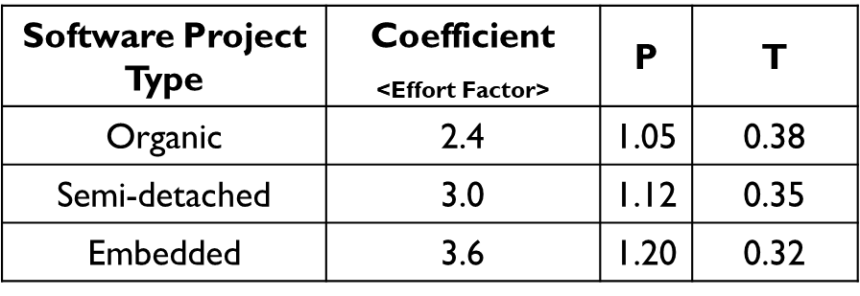

As our project falls into Organic Type, then:

1. Coefficient = 2.4
2. P = 1.05
3. T = 0.38
4. SLOC = 38000

Effort = PM = Coefficient<Effort Factor>*(SLOC/1000)^P

= 2.4*(30000/1000)^1.05 = 85.94

Development time = DM = 2.50*(PM)^T

= 2.50*(85.94)^0.38

= 13.59

Required number of people = ST = PM/DM

= 85.94 / 13.59

= 6.32

This calculation shows our Project will require more than 13 months to complete. So, we will take 14 months overall to complete this project.

This calculation also shows, we will need 7 person to develop this project.

1. **Human Resource:**

* Project Manager (1)

* System Administrator (1)

* System Analyst (1)

* Web Designer (2)

* Database Engineer (1)

* Tester (1)

1. **Cost Estimation:**

**Product Cost:**

* Rent ($450)

* IPS ($220)

* Computer ($350)

* Internet ($100)

* Oracle ($45)

* Pencil ($8)

* Photoshop ($43)

* Food ($200)

Total Product Cost: $1416/month

**Salary Expenses:**

* Project Manager ($950)

* System Administrator ($700)

* System Analyst ($540)

* Web Developer ($410)

* Database Engineer ($620)

* Tester ($440)

Total Salary Expenses: $3660/month

Total Cost: $1416 + $3660 = $4795/month

**Project Budget Estimation:**

Total Budget **=** Total Cost * Project Duration in Month

= $5076 * 14

= $71064

1. **Required Tools:**

**\*** Oracle Server

* Pencil

* Photoshop

* Visual Studio Code

* GitHub

**Business Requirements**

**Amendment History:**

|  |  |  |  |
| --- | --- | --- | --- |
| **Version** | **Prepared By** | **Date** | **Description** |
| 1.0 | 1) SAHA, ATANU  2) MIAH, MD.BADHON  3) HASSAN, TANVIR  4) MAHMUD, MD. AFSAR | 09-09-2020 | First Version |

**Stockholder Identification:**

|  |  |  |
| --- | --- | --- |
| **Stockholder Name** | **Organization** | **Role** |
| SAHA, ATANU | Call in a Doctor | President |
| MIAH, MD.BADHON | Call in a Doctor | Treasure |
| HASSAN, TANVIR | Call in a Doctor | Secretary |
| MAHMUD, MD. AFSAR | Call in a Doctor | Vice President |

**Business Purpose:**

This is a type of system from where people can be benefitted as well as the stockholders will be benefitted. User will be able to get system services and to get that services they have to pay some amount of money form where stockholders will be benefitted. In later version we will advertise products in our system and form that the stockholders will be able to earn some amount of money.

**Business Opportunity:**

In current situation, we have collaboration with limited hospitals but we expect in future the number of hospitals will be increased. Because of this, number of users both patient and doctors will be increased which will increase the business opportunity. As the system will grow day by day, we expect to get shares from other companies.

**Case Study:**

In an online call in a doctor system, a user (patient/doctor) places a request to the system for registration. The system then gets all the carrier names and their time schedules in the system server. System can verify and cancel the request if it failed to verify the user. User (patient/doctor) can login into the system through the username and password. If a user (patient) log in to the system he/she will find 3 categories. User can choose any option as his/her need. If user chooses “Online doctor”, then he/she will be able to confirm his/her appointment through system’s functionality. To confirm the appointment user must have to go through a payment procedure. After a successful payment procedure, the system will reserve user’s information as an appointee and will return a schedule for consultation via SMS. If a user (patient) chooses “Meet a doctor” he/she can give an appointment request through the system to the doctor’s chamber and from the chamber a schedule and serial number will be provided to the user via SMS. To confirm the appointment user must have to go through a payment procedure. After a successful payment the appointment will be confirmed. If a user chooses “Call in a doctor” he/she can send request to the selected doctors according to user’s area for emergency treatment. If doctor accept the request user have to go through a payment procedure. After payment system will confirm the doctor that schedule is confirmed. If a user (patient) chooses “Immediate ICU” he/she can see available ICU’s information according to his/her location. If user click on any hospital’s icon, he/she can see details information. If user chooses “Free doctor”, he/she will be able to book a slot for free by maintaining the system criteria.

If a user (doctor) log in to the system, he/she can see her profile and the consulting requests from the user. User (doctor) can update his/her profile continuously.

**Use case diagram for call in a doctor:**

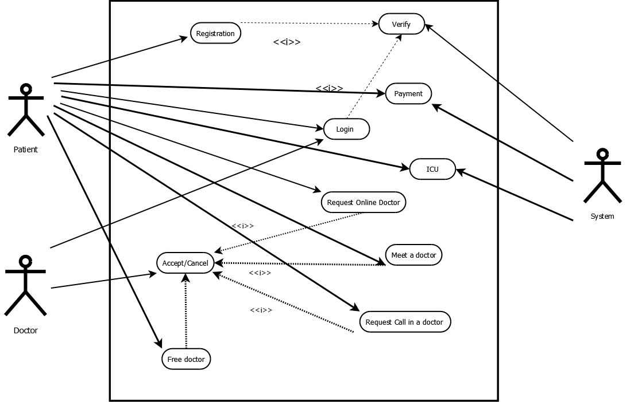

**Class diagram for call in a doctor:**

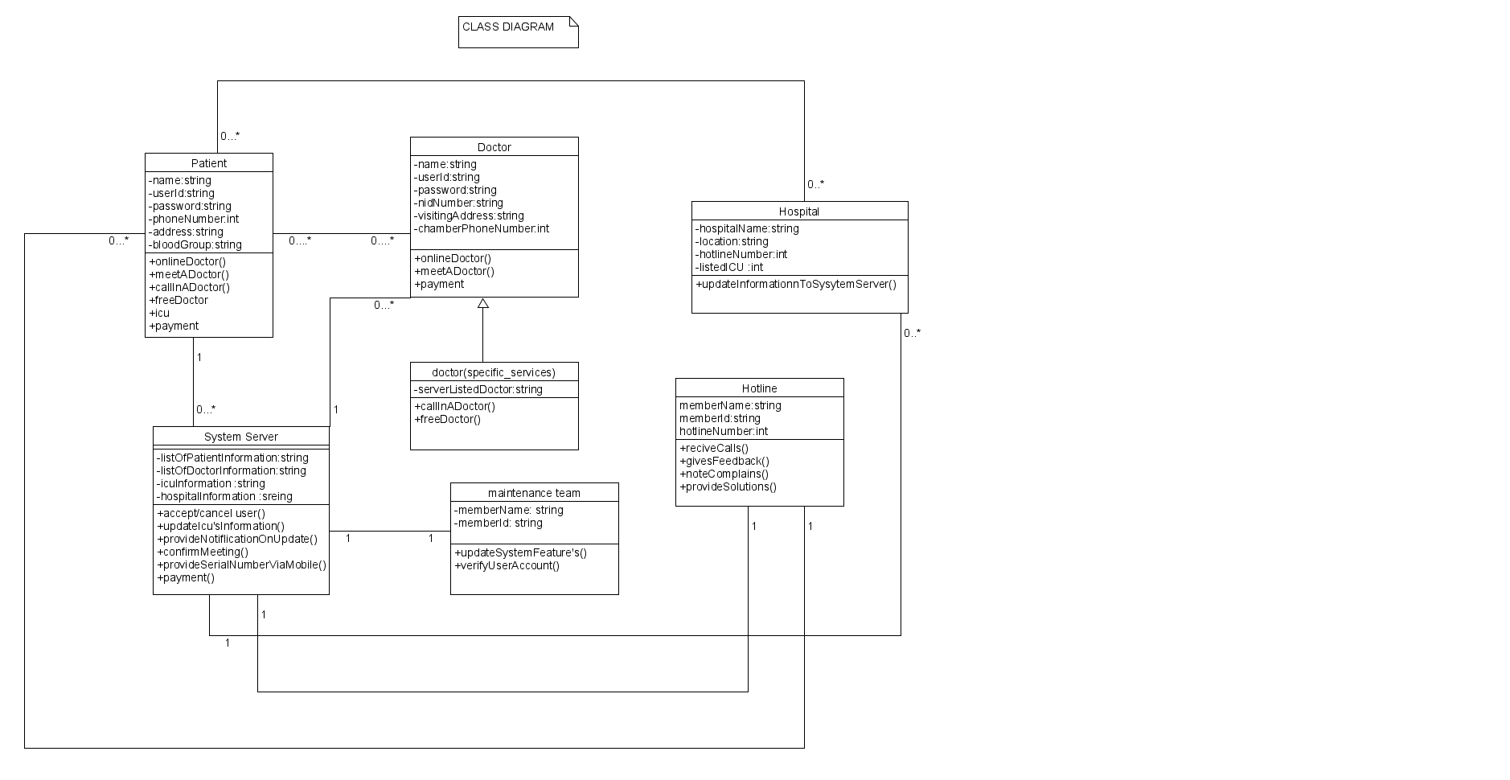

**Activity diagram for call in a doctor:**

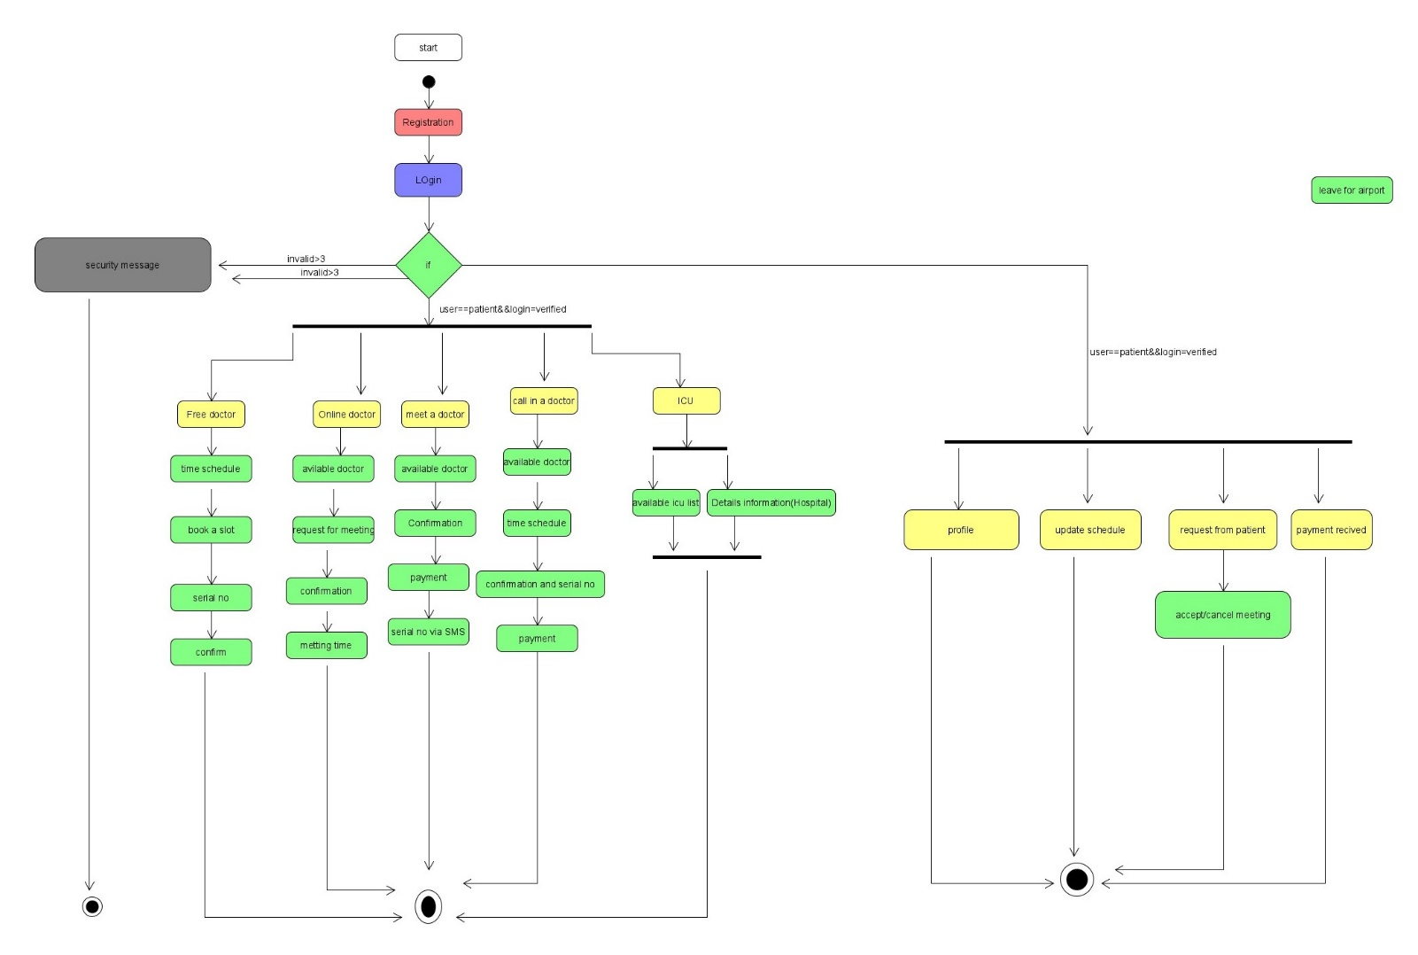

**ER diagram for call in a doctor:**

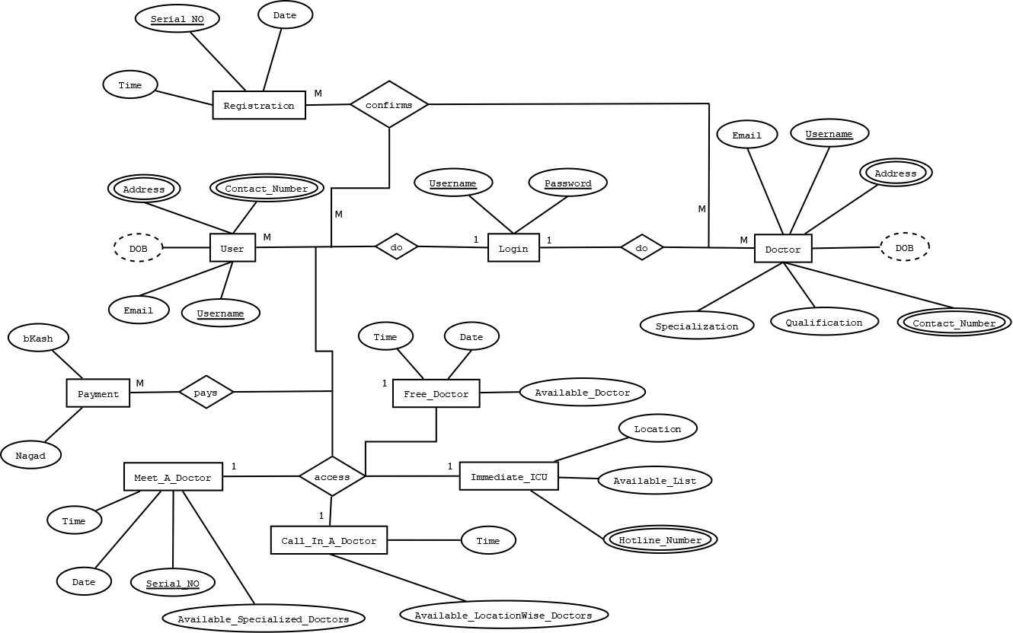

**Model Selection:**

The software development models are the various processes or methodologies that are being selected for the development of the project depending on the project's aims and goals. There are many development life cycle models that have been developed in order to achieve different required objectives. For our project we select the AGILE SOFTWARE DEVELOPMENT MODEL.

Agile is lightweight iterative model. In this model the time duration per scope is at best one month. In our project, we have some functionality which are characterized into specific parts for which the time duration (<=1month) is best for us. In software development the shorter time period is more useful because in lower time period a software development team develop a lower amount of functionalities than the bigger time period. And if we made any mistake during this time box we can easily solve our errors. One of the best practice in agile model has in every iteration after the work successful testing is necessary. Testing is the one of the best way to find out the errors or system bug. If we find out our bugs soon then it will be helpful to solve this small amount of bug. In future if system need any kind of change it is necessary to build proper documentation of the system which we will keep writing in each iteration. Agile development means automation and efficiency. Each member of the team is focused on the goal, the idea of the project is thin, each member knows the amount of effort it needs to put into the project and meet the demands. In teamwork, there is a need to have a look at the tasks each member performs, how tasks are categorized and what should be working strategy to be followed by each member. Software development requires tools to manage the project efficiently. This would help in understanding the project, categorizing the requirements of the project, prioritizing the tasks, assigning the tasks to the appropriate person in the team, following the project timeline efficiently. Every software is developed for specific design and specific people. So customer satisfaction is the major issues. Agile is the people base model rather than the paper base. So by using agile we can understand the customer feedback early because the “TimeBox” of every scope is at best one month so we can make small amount of functionalities and make a test and we understand either the functionalities are good or bad, if any change is required we can easily do it.

For all of those reason we selected agile is the best and suitable model for our Call in a doctor project.

**Call In a Doctor Interfaces**

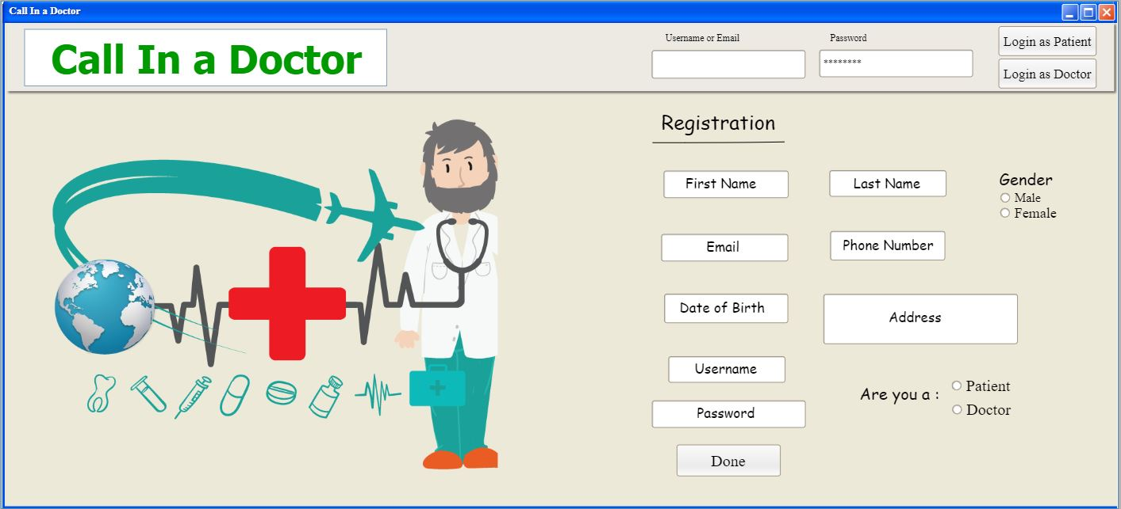

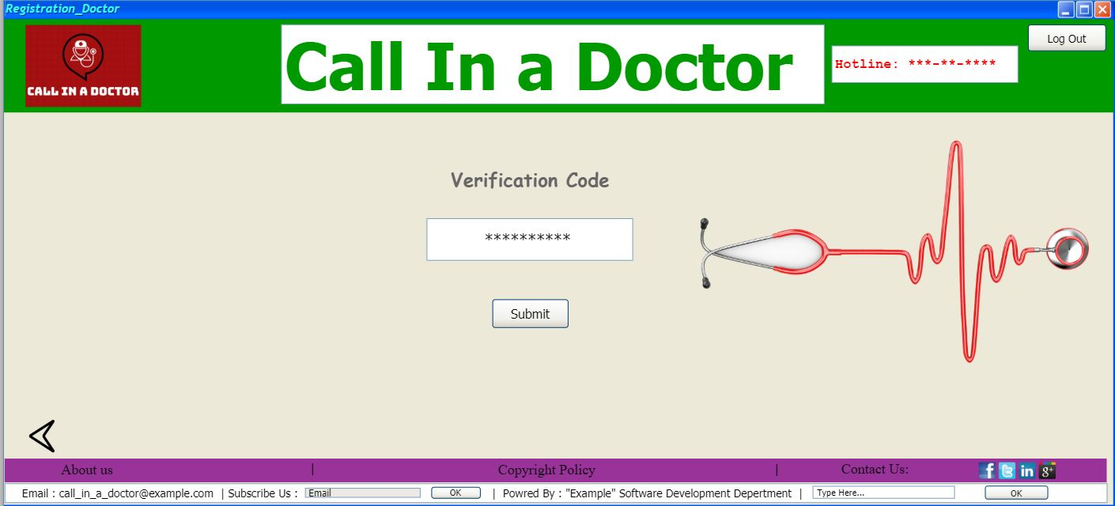

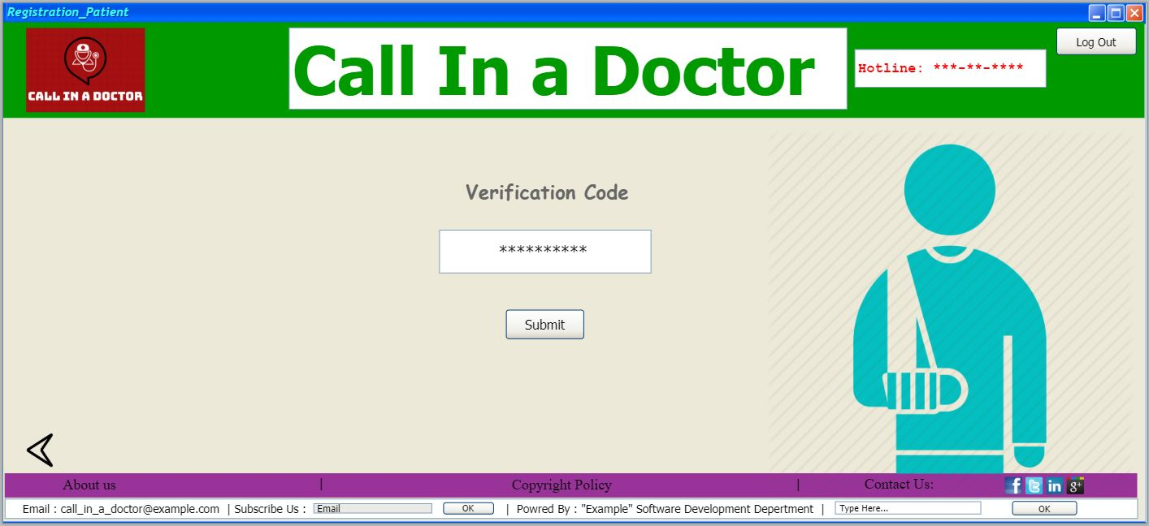

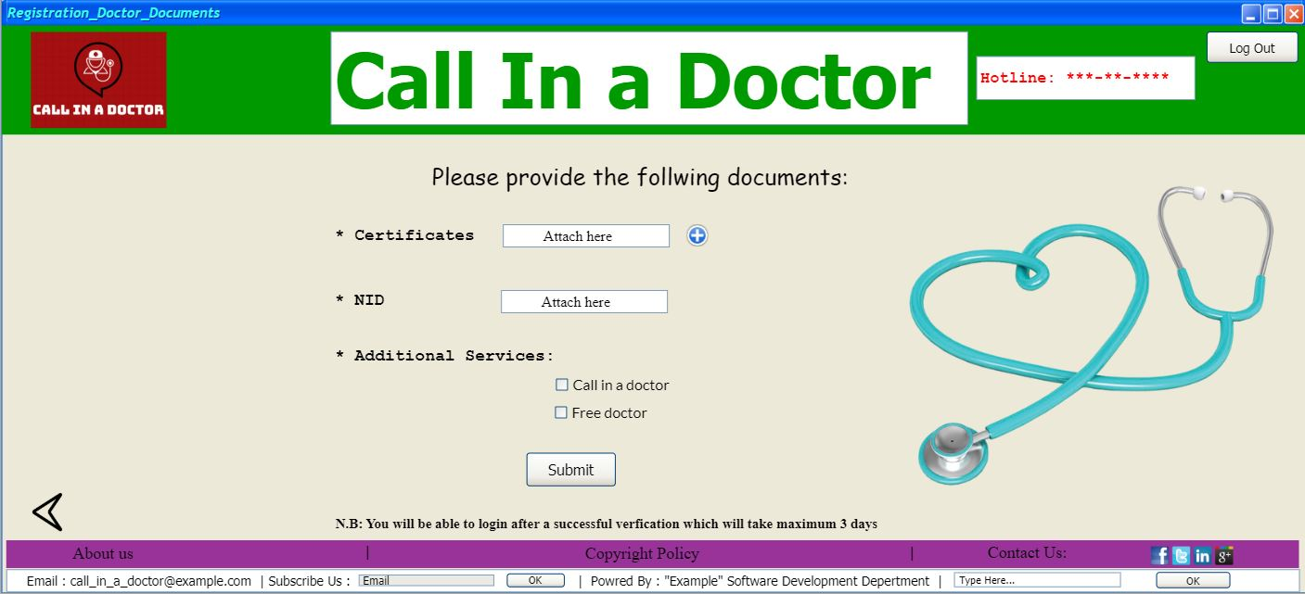

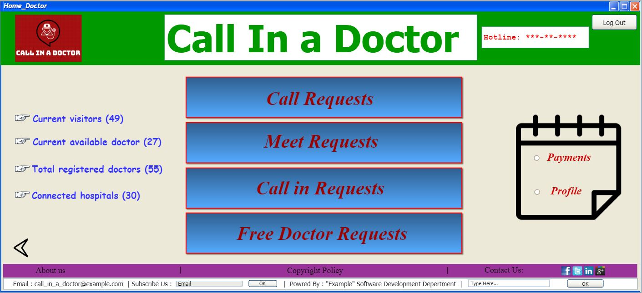

**For patient**

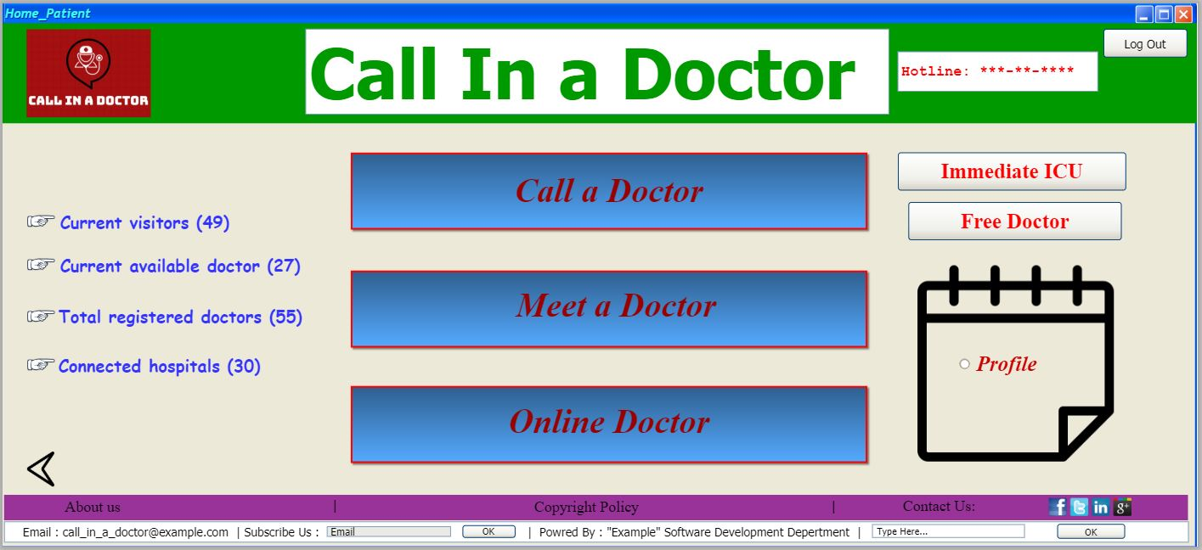

**For patient**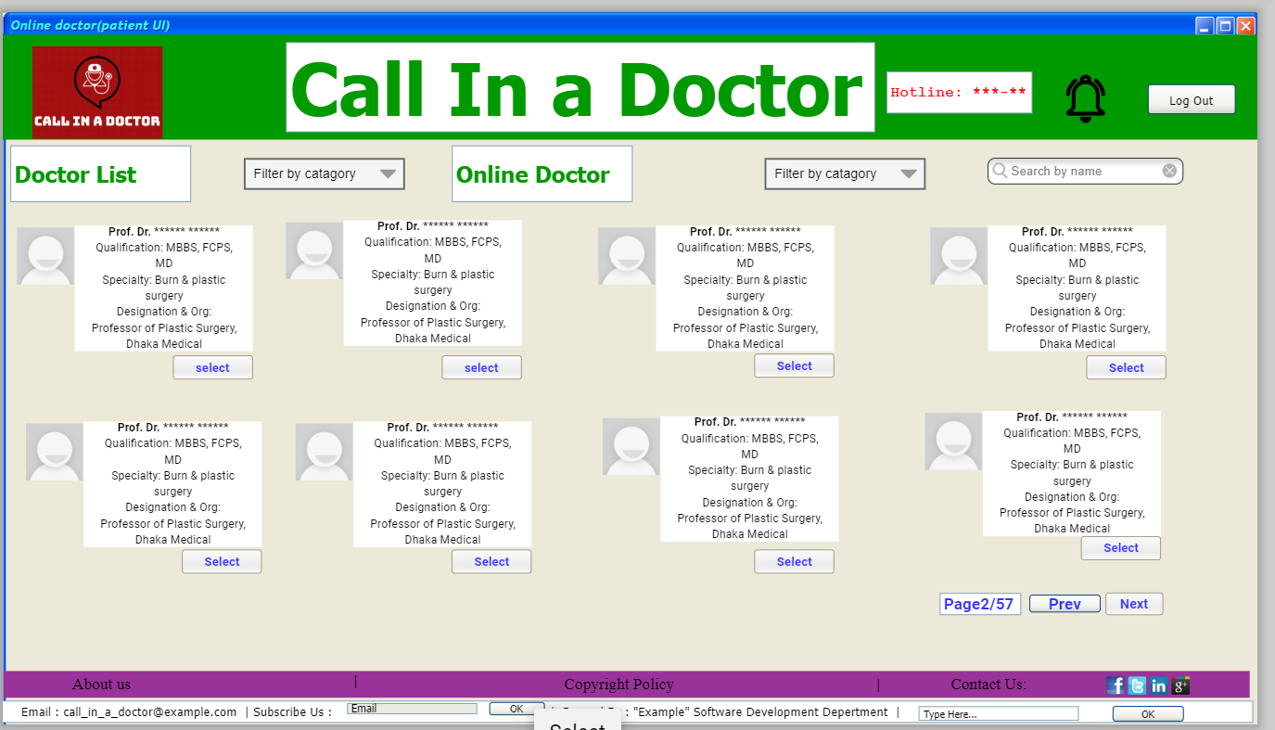

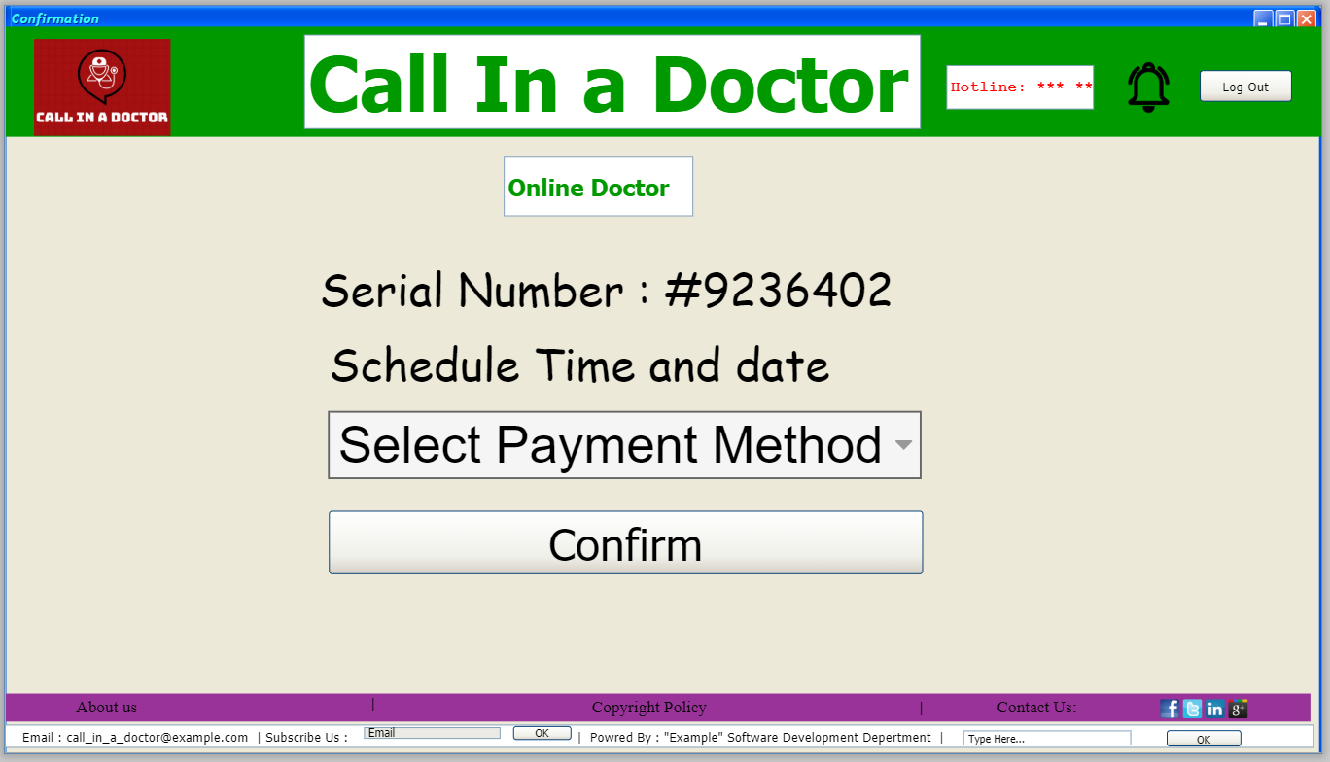

**For doctor**

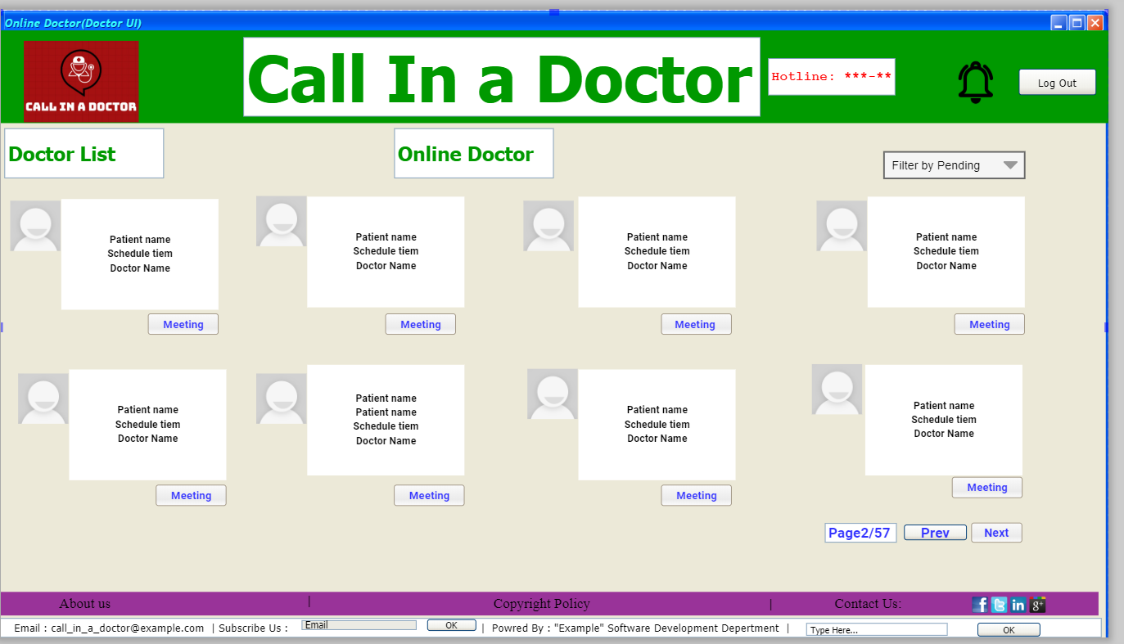

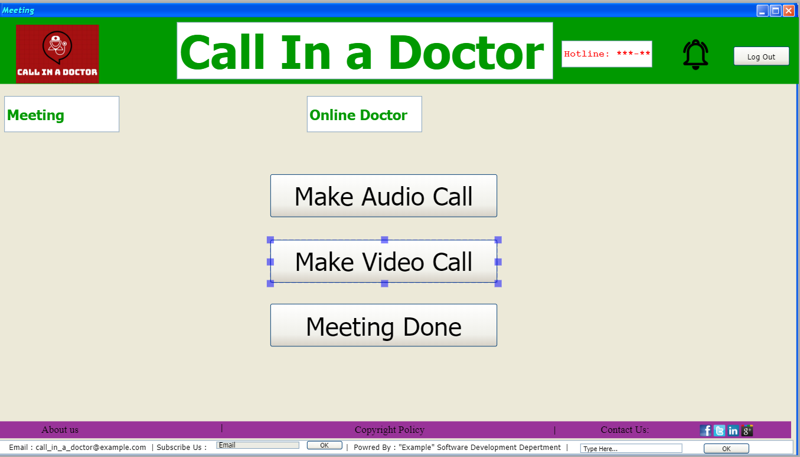

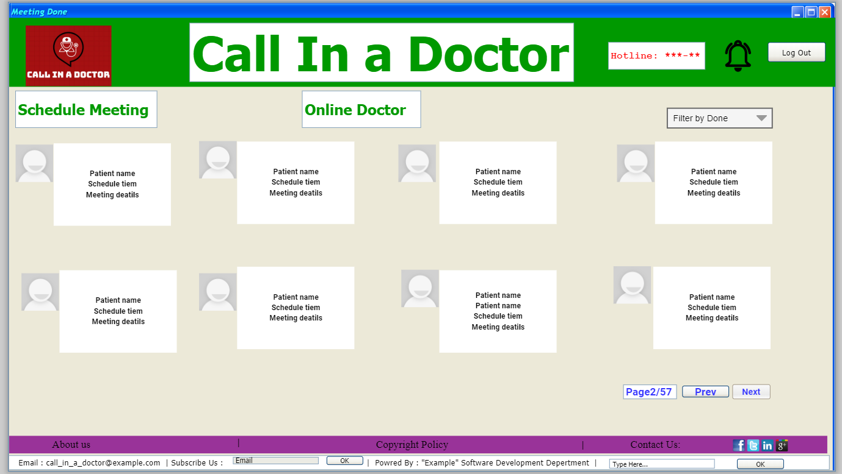

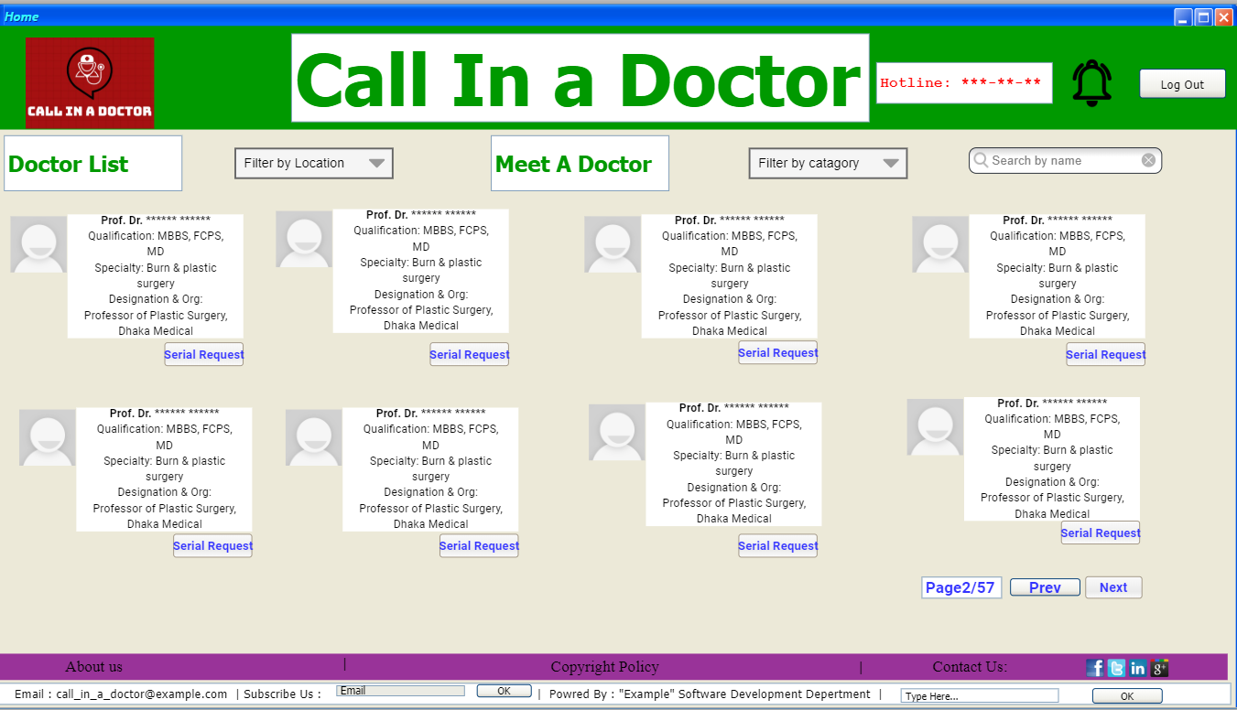

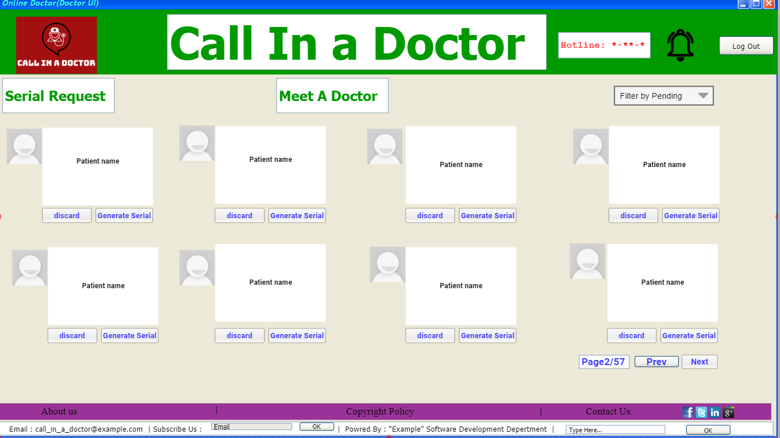

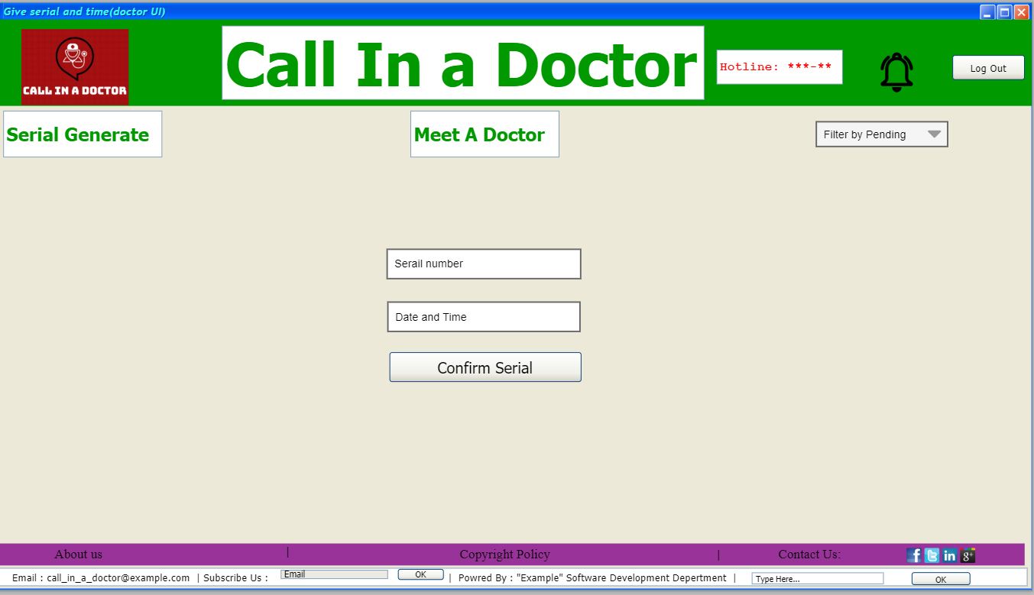

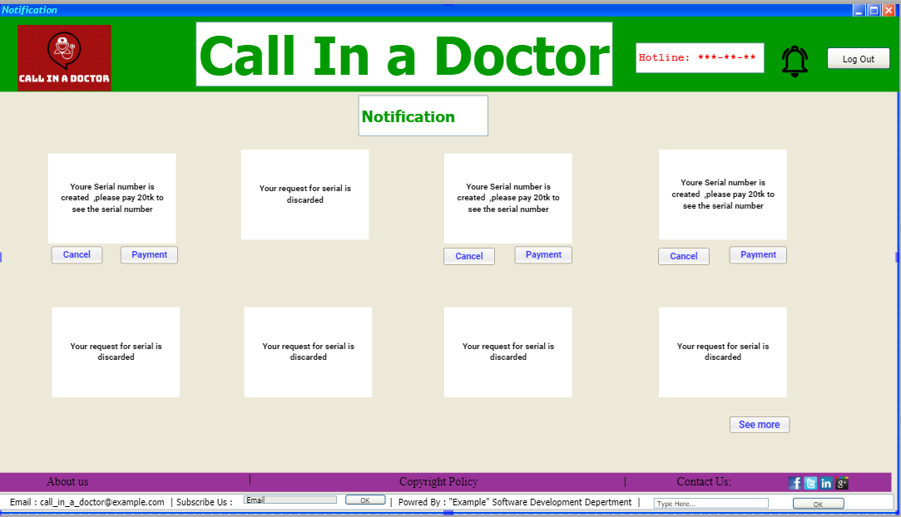

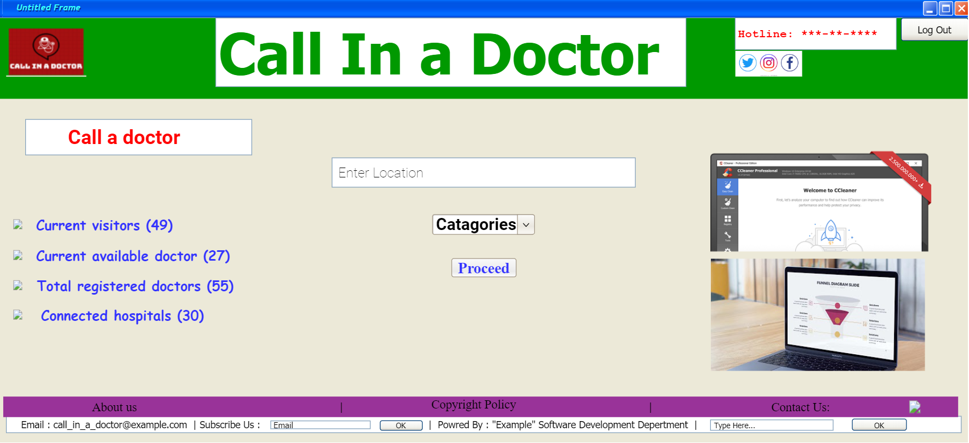

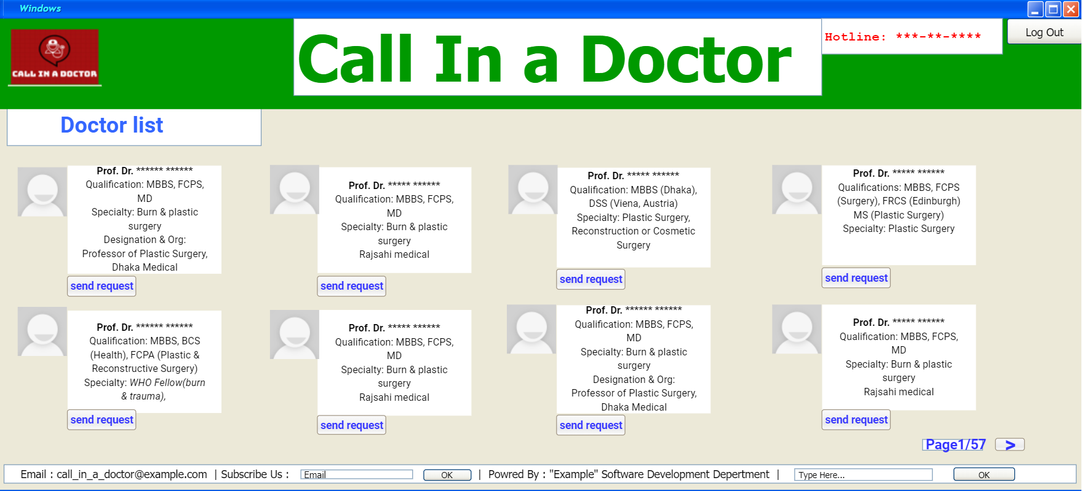

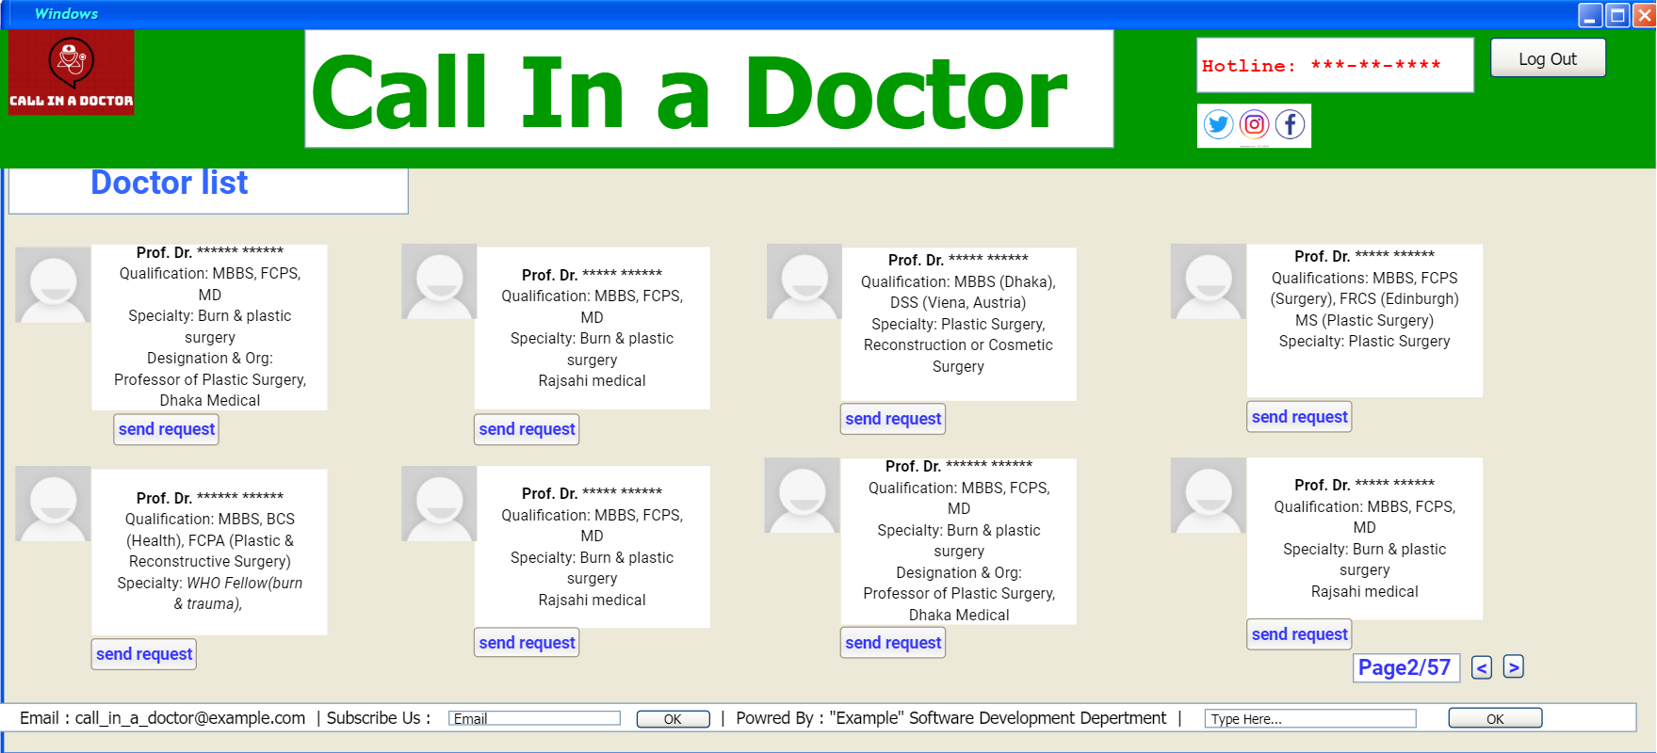

**For doctor**



**For Patient:**



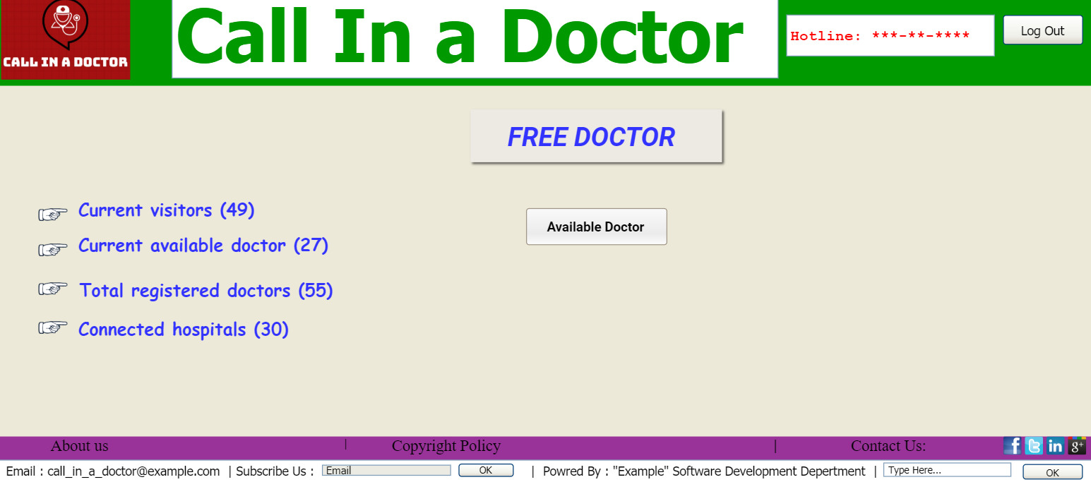

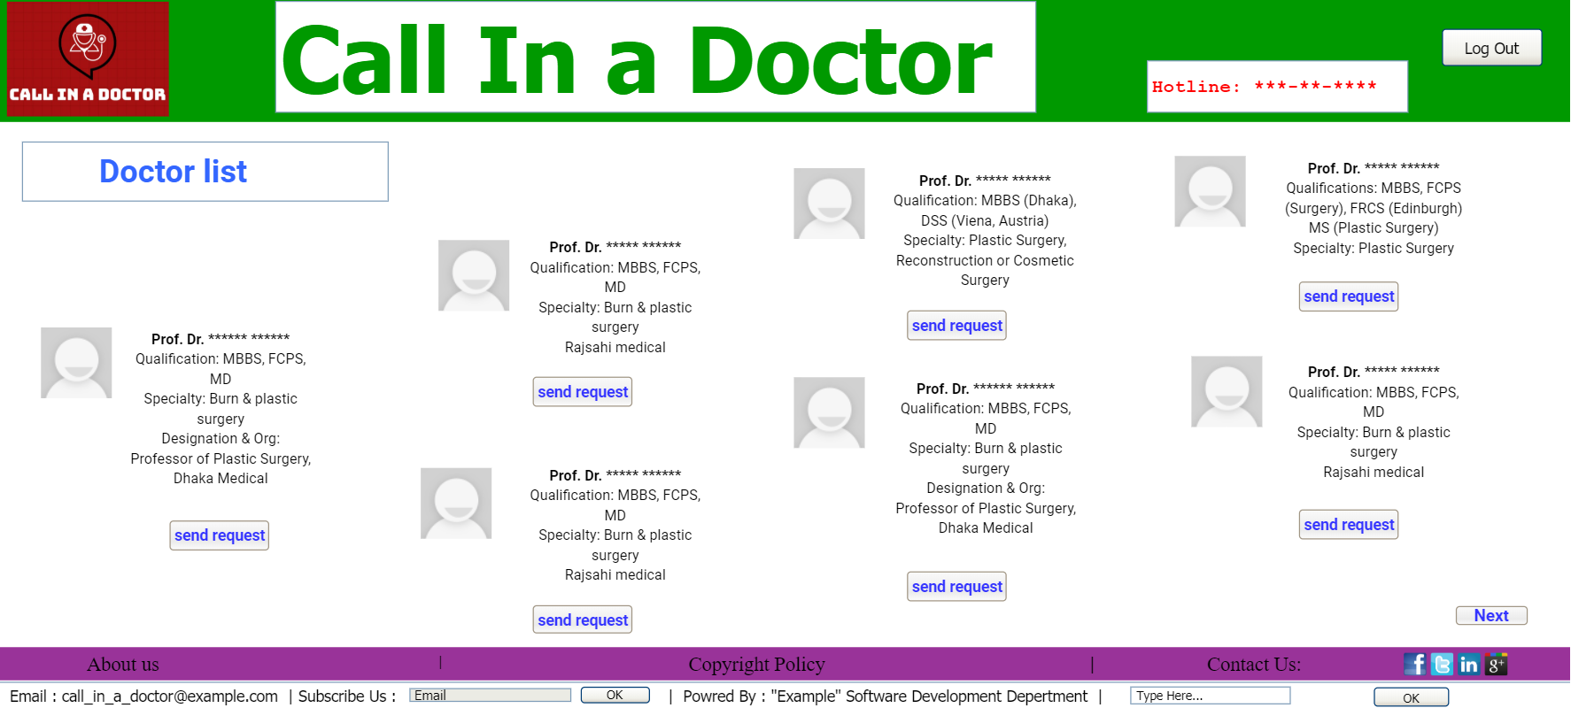

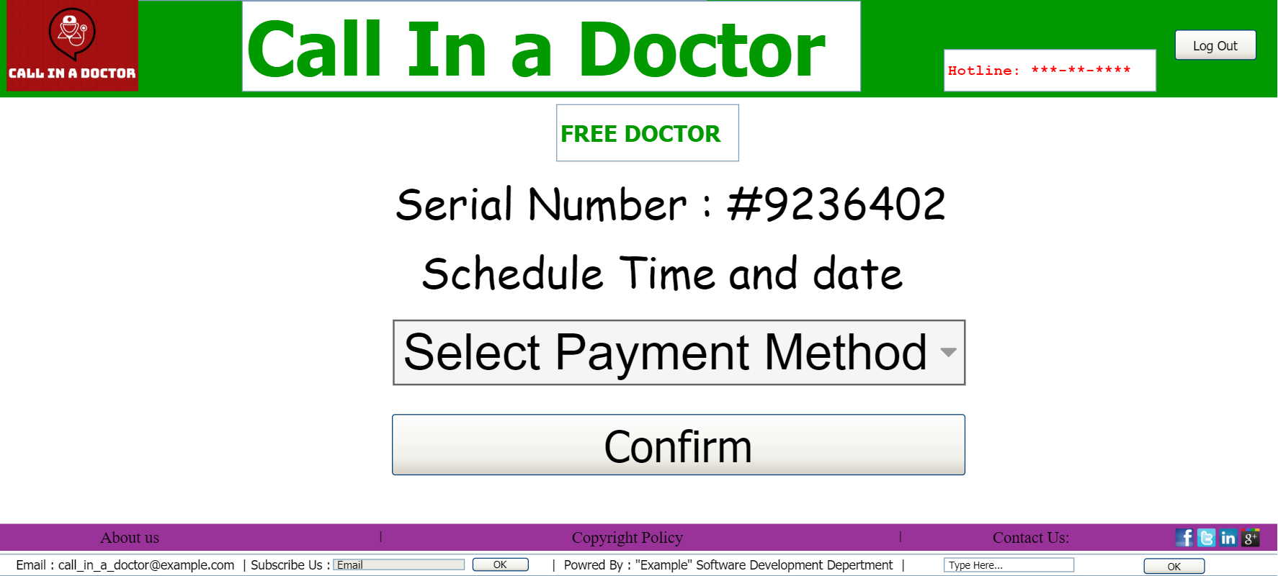

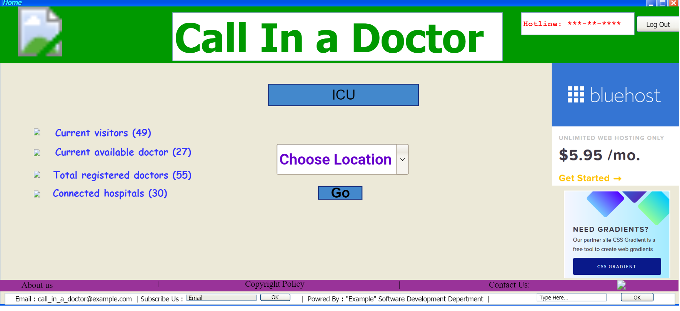

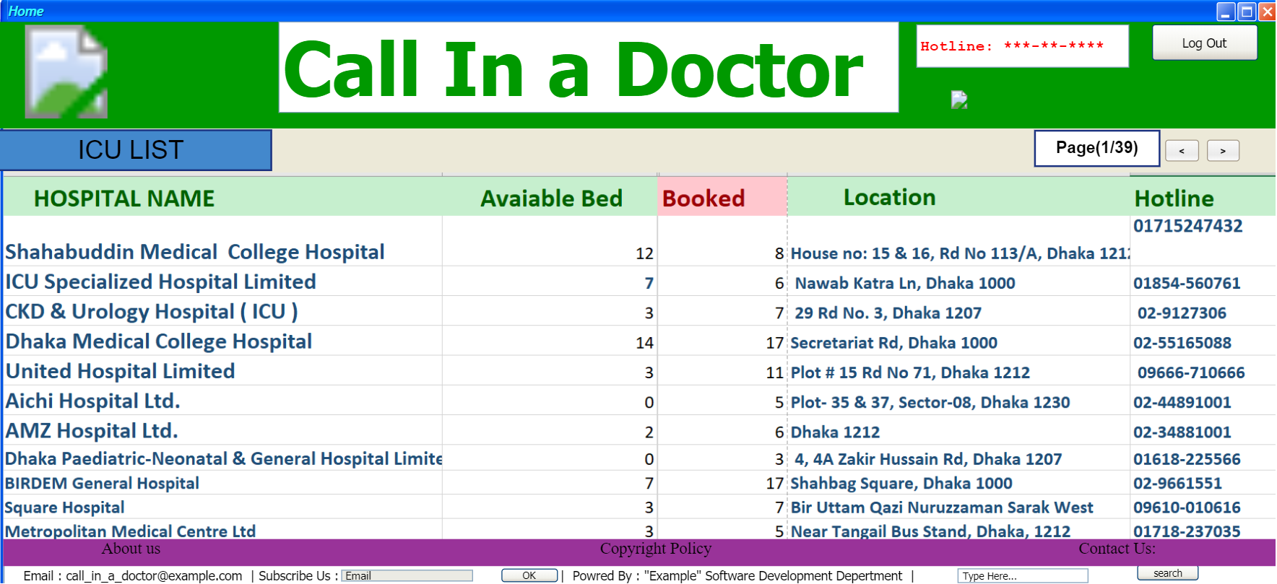

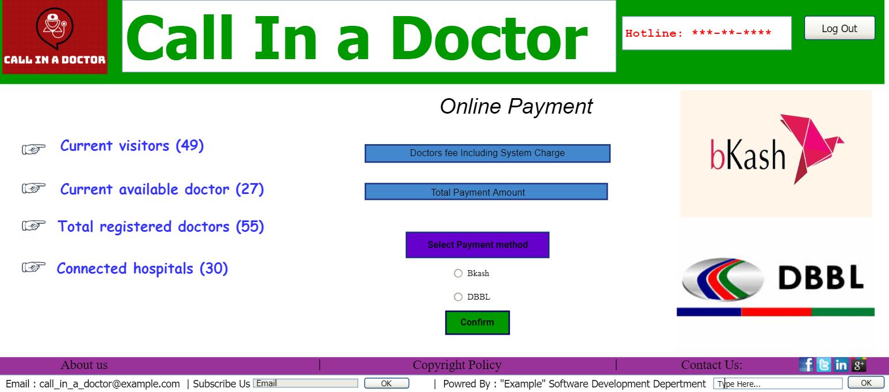

**Test Cases**

**Test cases: Registration**

|  |  |  |  |  |
| --- | --- | --- | --- | --- |
| Project Name: Call in a Doctor | | | Test Designed by: SAHA, ATANU | |
| Test Case ID: FR_1 | | | Test Designed date: 26-08-20 | |
| Test Priority (Low, Medium, High): High | | | Test Executed by: | |
| Module Name: Registration Session | | | Test Execution date: | |
| Test Title: Validation of personal information with username and password and registration. | | | | |
| Description: Registration of Patient contains personal information and username-password combo which is appended in the database after successful validation (Instant Test Procedure). Registration of Doctor contains personal information with attachment and username-password combo which is appended in the database after successful validation (Long Test Procedure). | | | | |
| Preconditions: N/A | | | | |
| Test Steps | Test Data | Expected Results | Actual Results | Status  (Pass/Fail) |
| 1. Go to the website  For Patient:  2. Enter required information and username and password  For Doctor:  2. Enter required information, attach file and username and password  3. Click submit | For Patient:  Username:  alice_143  Password:  Security101princess  Verification code:  675754  For Doctor:  Username:  bob_007  Password:  master_surgeon  Verification code:  132435 | For Patient:  User should be able to register.  For Doctor:  User should be able to register if all information seems legit. |  |  |
| Post condition: User information is validated and appended in the database. | | | | |

**Test cases: Login**

|  |  |  |  |  |
| --- | --- | --- | --- | --- |
| Project Name: Call in a Doctor | | | Test Designed by: SAHA, ATANU | |
| Test Case ID: FR_2 | | | Test Designed date: 26-08-20 | |
| Test Priority (Low, Medium, High): High | | | Test Executed by: | |
| Module Name: Login Session | | | Test Execution date: | |
| Test Title: Verify login with valid username and password. | | | | |
| Description: Successful login will pass login credentials through database. | | | | |
| Preconditions: User must have valid username and password. | | | | |
| Test Steps | Test Data | Expected Results | Actual Results | Status  (Pass/Fail) |
| 1. Go to the website  For Patient:  2. Enter username and password  For Doctor:  2. Enter username and password  3. Click submit | For Patient:  Username:  alice_143  Password:  Security101princess  For Doctor:  Username:  bob_007  Password:  master_surgeon | For Patient:  User should be able to login into the web.  For Doctor:  User should be able to login into the web. |  |  |
| Post condition: User is validated with database and successfully login to account. The account session details are appended in the database. | | | | |

**Test cases: Online Doctor**

|  |  |  |  |  |
| --- | --- | --- | --- | --- |
| Project Name: Call in a Doctor | | | Test Designed by: MIAH,MD.BADHON | |
| Test Case ID: FR_3 | | | Test Designed date:26-08-2020 | |
| Test Priority (Low, Medium, High): High | | | Test Executed by: | |
| Module Name: Online Doctor | | | Test Execution date: | |
| Test Title: To check Online doctor module is work perfectly. | | | | |
| Description: Online doctor module is the platform where a user can meet with a doctor through online and patients can make e request for his/her choose doctor. | | | | |
| Preconditions: Should be valid users. | | | | |
| Test Steps | Test Data | Expected Results | Actual Results | Status  (Pass/Fail) |
| 1. All types of Searching should be work perfectly within 15 sec.  For Patient:  2. Payment validation.  3. Notify Patients about appointment information. | 1.  Dr. Bruce  Dr. Robert  Location: Dhaka  Category : Burn unit  2.Code:832683  Seral no;20 | 1. Users should be done all types of searching without any major buffering within 10 sec.  2. We have to confirm that there should not be any kind of security problem and validate the payment system.  3. After confirmation system will notify the patients about appointment time and date. |  |  |
| Post condition: Database should be update properly and insert all data into the database. | | | | |

**Test cases: Meet a doctor**

|  |  |  |  |  |
| --- | --- | --- | --- | --- |
| Project Name: Call in a Doctor | | | Test Designed by: MIAH,MD.BADHON | |
| Test Case ID: FR_4 | | | Test Designed date: 26-08-2020 | |
| Test Priority (Low, Medium, High): High | | | Test Executed by: | |
| Module Name: Meet a doctor | | | Test Execution date: | |
| Test Title: To check the meet a doctor module work perfectly | | | | |
| Description: Make sure the meet a doctor module is working perfectly by checking serial request and confirmation as well as discard. | | | | |
| Preconditions: Must have valid users. | | | | |
| Test Steps | Test Data | Expected Results | Actual Results | Status  (Pass/Fail) |
| 1. All types of Searching should be work perfectly within 15 sec.  For Patient:  2. Payment validation.  For doctor:  3. Notify doctor about appointment information. | 1.  Dr. Clerk  Location :Dhaka  Category : Burn unit  2.Code:832683  Seral no;20 | 1. Users should be done all types of searching without any major buffering within 10 sec.  2. We have to confirm that there should not be any kind of security problem and validate the payment system.  3. System should be notify the doctor about the appointment request. |  |  |
| Post condition: Confirmation should be update in the proper time. | | | | |

**Test cases: Call in a doctor**

|  |  |  |  |  |
| --- | --- | --- | --- | --- |
| Project Name: Call in a Doctor | | | Test Designed by: MAHMUD, MD. AFSAR | |
| Test Case ID: FR_5 | | | Test Designed date: 26-08-2020 | |
| Test Priority (Low, Medium, High): High | | | Test Executed by: | |
| Module Name: Call in a Doctor | | | Test Execution date: | |
| Test Title: Searching doctor and send a request to doctor | | | | |
| Description: Call in a doctor, For patient: will able to search doctors with different categories and send request to the doctors by doing a successful payment. For doctor: doctors can accept or decline the requests. Both of the user can give feedback after the meeting to the system. | | | | |
| Preconditions: Log in to the system with valid username and password. | | | | |
| Test Steps | Test Data | Expected Results | Actual Results | Status  (Pass/Fail) |
| For Patient:  1. All types of Searching should be work perfectly within 15 sec.  2. User can send request to their preferred doctor.  3. Payment validation  4. Feedback submission  For Doctor:  1. Doctor can accept or decline requests.  2. Feedback submission | For Patient:  Doctor’s Category:  Bone specialist  Location:  Dhaka  Payment validity:  Transaction code: 157934  Serial number: 37 | For Patient:  1. User should be able to send request for a doctor.  2. User should be able to make payment and get a serial number  For Doctor:  User should be able Accept or decline the request.  For Patient and doctor:  User should be able to give feedback about their doctor/patient |  |  |
| Post condition: User information is validated and appended in the database. | | | | |

**Test cases: ICU**

|  |  |  |  |  |
| --- | --- | --- | --- | --- |
| Project Name: Call in a Doctor | | | Test Designed by: MAHMUD, MD. AFSAR | |
| Test Case ID: FR_6 | | | Test Designed date: 26-08-2020 | |
| Test Priority (Low, Medium, High): High | | | Test Executed by: | |
| Module Name: Immediate ICU | | | Test Execution date: | |
| Test Title: Verify searching an ICU | | | | |
| Description: Successful search for available ICU | | | | |
| Preconditions: Must have a username and password | | | | |
| Test Steps | Test Data | Expected Results | Actual Results | Status  (Pass/Fail) |
| For Patient:  All types of Searching should be work perfectly within 15 sec.  For Hospitals:  All types of Searching should be work perfectly within 15 sec. | For Patient:  Searching:  Dhaka medical Hospital.  Location:  Dhaka  Update ICU beds:  Available:3 ,used:9 | For Patient:  User should be able to find the expected Hospital  User should be able to update the hospitals ICU bed’s information |  |  |
| Post condition: User is validated with database and successfully login to account. | | | | |

**Test cases: Free Doctor**

|  |  |  |  |  |
| --- | --- | --- | --- | --- |
| Project Name: Call in a Doctor | | | Test Designed by: HASSAN TANVIR | |
| Test Case ID: FR_7 | | | Test Designed date:26-08-2020 | |
| Test Priority (Low, Medium, High): Medium | | | Test Executed by: | |
| Module Name: Free Doctor | | | Test Execution date: | |
| Test Title: To check free doctor module is work perfectly. | | | | |
| Description: Free doctor, for patient: will able to search doctors with different categories and send request to the doctors by doing a successful payment. For doctor: doctors will check his/her free schedule and then he/she can accept or decline the requests. Both of the user can give feedback after the meeting to the system. | | | | |
| Preconditions: Should be valid users. | | | | |
| Test Steps | Test Data | Expected Results | Actual Results | Status  (Pass/Fail) |
| 1. Updated doctor  Schedule with limited addition will provided with their respective free consulting hours  For Patient:  2. Payment validation.  3. Notify Patients about appointment information. | 1.Dr. Rouf  Bone Specialist  Consulting hour : 3-5 pm  Location: Dhaka  2.Code:832685  Seral no :20 | 1. Users can choose their respective doctor schedule.  2. We have to confirm that there should not be any kind of security problem and validate the payment system.  3. After confirmation system will notify the patients about appointment time and date. |  |  |
| Post condition: Database should be update properly and insert all data into the database. | | | | |

**Test cases: Payment**

|  |  |  |  |  |
| --- | --- | --- | --- | --- |
| Project Name: Call in a Doctor | | | Test Designed by: HASSAN TANVIR | |
| Test Case ID: FR_8 | | | Test Designed date: 26-08-2020 | |
| Test Priority (Low, Medium, High): High | | | Test Executed by: | |
| Module Name :Successful Payment | | | Test Execution date: | |
| Test Title : Verify security purpose to transfer money | | | | |
| Description: Verification of user identity with authentic source and complete patient’s doctor fees. | | | | |
| Preconditions: Must have valid users. | | | | |
| Test Steps | Test Data | Expected Results | Actual Results | Status  (Pass/Fail) |
| 1. Necessary available balance for doctor payment.  For Patient:  2. Payment confirmation  For Patient:  3. Payment validation.  For doctor:  4. Notify doctor about appointment information. | 1.Mr. Hassan  Account no : 7644844  Balance : 856789 $  2. Mr. Hassan  Doctor fees :700tk  3.Code:832683  Seral no;20 | 1. Users should have available balance to pay doctor fees.  2. Users have to pay doctor fees and confirm payment action.  3. We have to confirm that there should not be any kind of security problem and validate the payment system.  4. System should be notify the doctor about the appointment request. |  |  |
| Post condition: Confirmation should be update in the proper time. | | | | |

**NFR Test Cases**

**Test cases: Availability**

|  |  |  |  |  |
| --- | --- | --- | --- | --- |
| Project Name: Call in a Doctor | | | Test Designed by: SAHA, ATANU | |
| Test Case ID: NFR_1 | | | Test Designed date: 07-09-2020 | |
| Test Priority (Low, Medium, High): N/A | | | Test Executed by: | |
| Module Name: Availability | | | Test Execution date: | |
| Test Title: Response time of the system. | | | | |
| Description: At different time system will get different number of hits. According to that an available percentage has been set varying weekdays and weekends. It also includes time shift. | | | | |
| Preconditions: N/A | | | | |
| Test Steps | Test Data | Expected Results | Actual Results | Status  (Pass/Fail) |
| Go the website at different time on different days. | N/A | According to condition, system should response properly. |  |  |
| Post condition: N/A | | | | |

**Test cases: Performance**

|  |  |  |  |  |
| --- | --- | --- | --- | --- |
| Project Name: Call in a Doctor | | | Test Designed by: SAHA, ATANU | |
| Test Case ID: NFR_2 | | | Test Designed date: 07-09-2020 | |
| Test Priority (Low, Medium, High): N/A | | | Test Executed by: | |
| Module Name: Performance | | | Test Execution date: | |
| Test Title: Performance of the system based on some activities of the system. | | | | |
| Description: At different action, system should response properly according to expected time. This includes the parts like authentication time, download time, searching time, and validation time. | | | | |
| Preconditions: N/A | | | | |
| Test Steps | Test Data | Expected Results | Actual Results | Status  (Pass/Fail) |
| Measuring time on the action of authentication, download, search, validation. | N/A | According to expected time, system should response properly. |  |  |
| Post condition: N/A | | | | |

**Test cases: Efficiency**

|  |  |  |  |  |
| --- | --- | --- | --- | --- |
| Project Name: Call in a Doctor | | | Test Designed by: SAHA, ATANU | |
| Test Case ID: NFR_3 | | | Test Designed date: 07-09-2020 | |
| Test Priority (Low, Medium, High): N/A | | | Test Executed by: | |
| Module Name: Efficiency | | | Test Execution date: | |
| Test Title: Increasing system efficiency and giving user a smooth experience with the help of a methodology. | | | | |
| Description: According to user’s internet speed, system will automatically reduce/increase images quality to give user a smooth experience. | | | | |
| Preconditions: N/A | | | | |
| Test Steps | Test Data | Expected Results | Actual Results | Status  (Pass/Fail) |
| Reduce/Increase the quality of system images. | N/A | According to user internet speed, system should response at its best. |  |  |
| Post condition: N/A | | | | |

**Test cases: Reusability**

|  |  |  |  |  |
| --- | --- | --- | --- | --- |
| Project Name: Call in a Doctor | | | Test Designed by: SAHA, ATANU | |
| Test Case ID: NFR_4 | | | Test Designed date: 07-09-2020 | |
| Test Priority (Low, Medium, High): N/A | | | Test Executed by: | |
| Module Name: Reusability | | | Test Execution date: | |
| Test Title: | | | | |
| Description: Many pages of the system contains search function. One search function code can be used in others module too. This reusability analogy can also be implemented in payment module. | | | | |
| Preconditions: N/A | | | | |
| Test Steps | Test Data | Expected Results | Actual Results | Status  (Pass/Fail) |
| Use of one code in many module. | N/A | According to the analogy of reusability, the system should response properly. |  |  |
| Post condition: N/A | | | | |

**Test cases:**  **Integrity**

|  |  |  |  |  |
| --- | --- | --- | --- | --- |
| Project Name: Call in a Doctor | | | Test Designed by: MIAH,MD.BADHON | |
| Test Case ID: NFR_5 | | | Test Designed date:07-09-2020 | |
| Test Priority (Low, Medium, High): N\A | | | Test Executed by: | |
| Module Name**:**  Integrity | | | Test Execution date: | |
| Test Title: To ensure the security of the system as well as the users. | | | | |
| Description: For security purpose system have to ensure the all kinds of security of the users, | | | | |
| Preconditions :N\A. | | | | |
| Test Steps | Test Data | Expected Results | Actual Results | Status  (Pass/Fail) |
| 1. System will able to prevent unauthorized access.  2. Only permitted privileges will be able to access user transaction histories.  3. Payment transactions procedure will be handled in special security. |  | 1. Have to ensure system will have to able to prevent all kinds of unauthorized access.  2. We have to confirm that there should be only admin or administrative team will see the transaction histories.  3. System should be give more security about payment and make sure that all kind of payment should be done without any kind of unsecure issues. |  |  |
| Post condition: N\A | | | | |

**Test cases:**  **Interoperability**

|  |  |  |  |  |
| --- | --- | --- | --- | --- |
| Project Name: Call in a Doctor | | | Test Designed by: MIAH,MD.BADHON | |
| Test Case ID: NFR_6 | | | Test Designed date:07-09-2020 | |
| Test Priority (Low, Medium, High): N\A | | | Test Executed by: | |
| Module Name**:**  N\A | | | Test Execution date: | |
| Test Title: To ensure the all kind of other build in system’s use of our system. | | | | |
| Description: for some purpose we used another system’s module to our project. | | | | |
| Preconditions :N\A. | | | | |
| Test Steps | Test Data | Expected Results | Actual Results | Status  (Pass/Fail) |
| 1. ICU information from every hospital will be updated in the system database.  2. Symmetric communication between system and payment methods will be establish when a transaction is occurred. |  | 1. Avaialable ICU information provide from hospital database and make sure it’s work perfectly.  2. System use the different payment method that are made by that companies.so we have to ensure the proper work of it. |  |  |
| Post condition: Database should be update properly and insert all data into the database. | | | | |

**Test cases: Reliability**

|  |  |  |  |  |
| --- | --- | --- | --- | --- |
| Project Name: Call in a Doctor | | | Test Designed by: MIAH,MD.BADHON | |
| Test Case ID: NFR_7 | | | Test Designed date: 07-09-2020 | |
| Test Priority (Low, Medium, High): N\A | | | Test Executed by: | |
| Module Name**:**  N\A | | | Test Execution date: | |
| Test Title: To ensure the system availability. | | | | |
| Description: Make sure how much time system will available with the total amount of time. | | | | |
| Preconditions : N\A. | | | | |
| Test Steps | Test Data | Expected Results | Actual Results | Status  (Pass/Fail) |
| 1. System will response more than or equal 99 times within 100 times. |  | 1. Make sure that system will available more than 99 times within 100 times. |  |  |
| Post condition: N\A | | | | |

**Test cases: Testability**

|  |  |  |  |  |
| --- | --- | --- | --- | --- |
| Project Name: Call in a Doctor | | | Test Designed by: MAHMUD, MD. AFSAR | |
| Test Case ID: NFR_8 | | | Test Designed date: 07-09-2020 | |
| Test Priority (Low, Medium, High): N\A | | | Test Executed by: | |
| Module Name**:**  N\A | | | Test Execution date: | |
| Test Title: To ensure test execution Cyclomatic complexity every module does not exceed 15. | | | | |
| Description: when we test some facture we have to ensure that Cyclomatic complexity every module does not exceed 15. | | | | |
| Preconditions :N\A. | | | | |
| Test Steps | Test Data | Expected Results | Actual Results | Status  (Pass/Fail) |
| 1. Only registration, login, search, payment modules has test data and according to Cyclomatic complexity every module does not exceed 15 which is a good limit to do performance. |  | 1. We have to ensure for test purpose as if Cyclomatic complexity every module does not exceed 15. |  |  |
| Post condition: N\A | | | | |

**Test cases: Robustness**

|  |  |  |  |  |
| --- | --- | --- | --- | --- |
| Project Name: Call in a Doctor | | | Test Designed by: MAHMUD, MD. AFSAR | |
| Test Case ID: FR_9 | | | Test Designed date: 07-09-2020 | |
| Test Priority (Low, Medium, High): N\A | | | Test Executed by: | |
| Module Name: Robustness | | | Test Execution date: | |
| Test Title: Auto save data for further use. | | | | |
| Description: All the information and activities will be auto save to prevent fail tolerance of the system. | | | | |
| Preconditions: N\A | | | | |
| Test Steps | Test Data | Expected Results | Actual Results | Status  (Pass/Fail) |
| 1. Saving information for further reuse |  | 1..filling up form or taking appointment for a doctor will be reserved in the database for further reuse |  |  |
| Post condition: N\A | | | | |

**Test cases: Usability**

|  |  |  |  |  |
| --- | --- | --- | --- | --- |
| Project Name: Call in a Doctor | | | Test Designed by : HASSAN TANVIR | |
| Test Case ID: FR_10 | | | Test Designed date: 07-09-2020 | |
| Test Priority (Low, Medium, High): N\A | | | Test Executed by: | |
| Module Name: Usability | | | Test Execution date: | |
| Test Title: To check user friendliness of the website | | | | |
| Description: How friendly users can use our website without having any difficulties | | | | |
| Preconditions: N\A | | | | |
| Test Steps | Test Data | Expected Results | Actual Results | Status  (Pass/Fail) |
| 1. System contains a simple UI because for this kind of system information and actions are more important.  2. A trained user shall be able to complete a web page within 5-6 minutes.  3. A fresh user may take to complete a web page within 10-15 minutes. |  | 1.Users can easily perform actions which are related to the website  2. Users who used this website before can easily interact with the actions.  3. New user needs a little bit lengthy time to cop up with the website. |  |  |
| Post condition: N\A. | | | | |

**Test cases: Maintainability**

|  |  |  |  |  |
| --- | --- | --- | --- | --- |
| Project Name: Call in a Doctor | | | Test Designed by: HASSAN TANVIR | |
| Test Case ID: FR_11 | | | Test Designed date: 07-09-2020 | |
| Test Priority (Low, Medium, High): N\A | | | Test Executed by: | |
| Module Name: Maintainability | | | Test Execution date: | |
| Test Title: how easily our website can be modified | | | | |
| Description: Maintainability depends on how easily website can be understood, changed, tested and correct a defect in our website. | | | | |
| Preconditions: N\A | | | | |
| Test Steps | Test Data | Expected Results | Actual Results | Status  (Pass/Fail) |
| 1. System contains light-weights UI and functions which gives a maintenance programmer to modify easily. |  | 1.System can easily modified, understood, changed and tested |  |  |
| Post condition: N\A | | | | |